

|  |
| --- |
| **Year 12 Mathematics Specialist 2017**  **Test Number 2: Functions and Graph Sketching**  **Resource Free** |

**Name: ________Solutions__________________________ Teacher: DDA**

**Marks: 20**

**Time Allowed: 22 minutes**

**Instructions:** You **ARE** **NOT** permitted any notes or calculator. Show your working where appropriate remembering you must show working for questions worth more than 2 marks.

_________________________________________________________________________

**Question 1 [3 marks]**

If determine the formula for the inverse of , and state its domain and range.

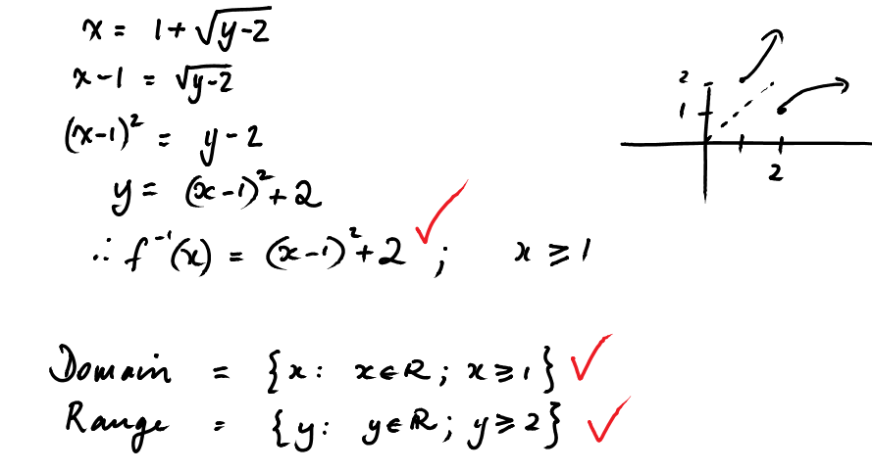

**Question 2 [3 marks]**

State the domain and range of if and .

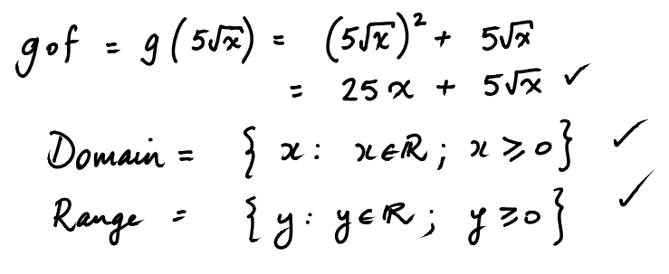

**Question 3 [2, 2, 2, 1 = 7 marks]**

1. On the graph below accurately draw: and
2. Using these, or otherwise, draw
3. Express this as a piecewise function

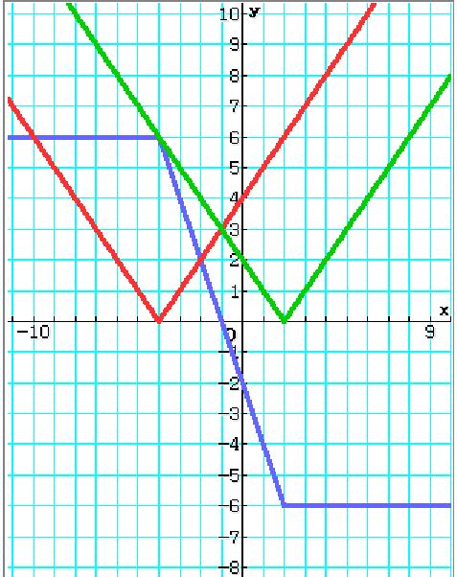



1. Use your graph to find the values of which satisfy:

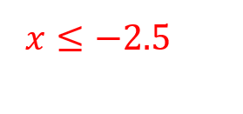

**Question 4 [2 marks]**

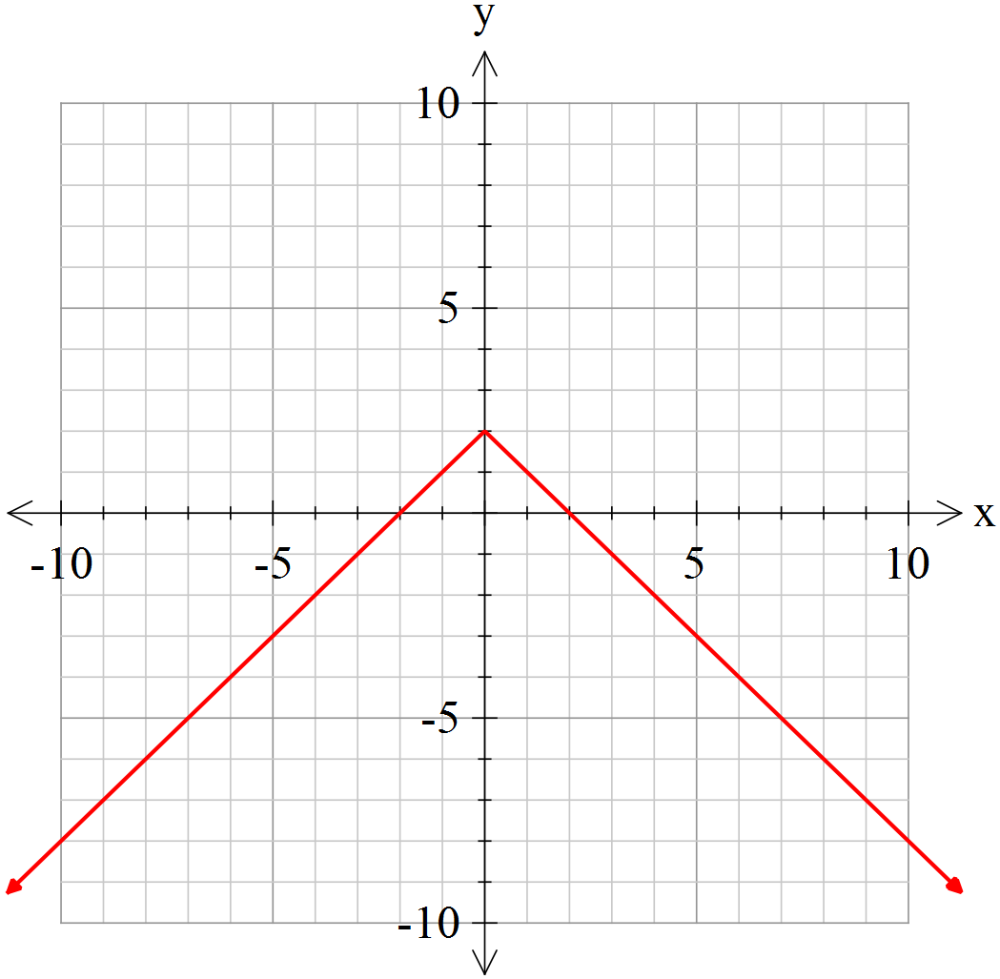Sketch the graph



**Question 5 [2, 1 = 3 marks]**

Sketch the graph of. Write the domain of.

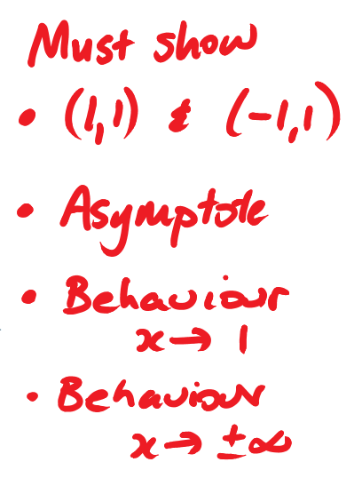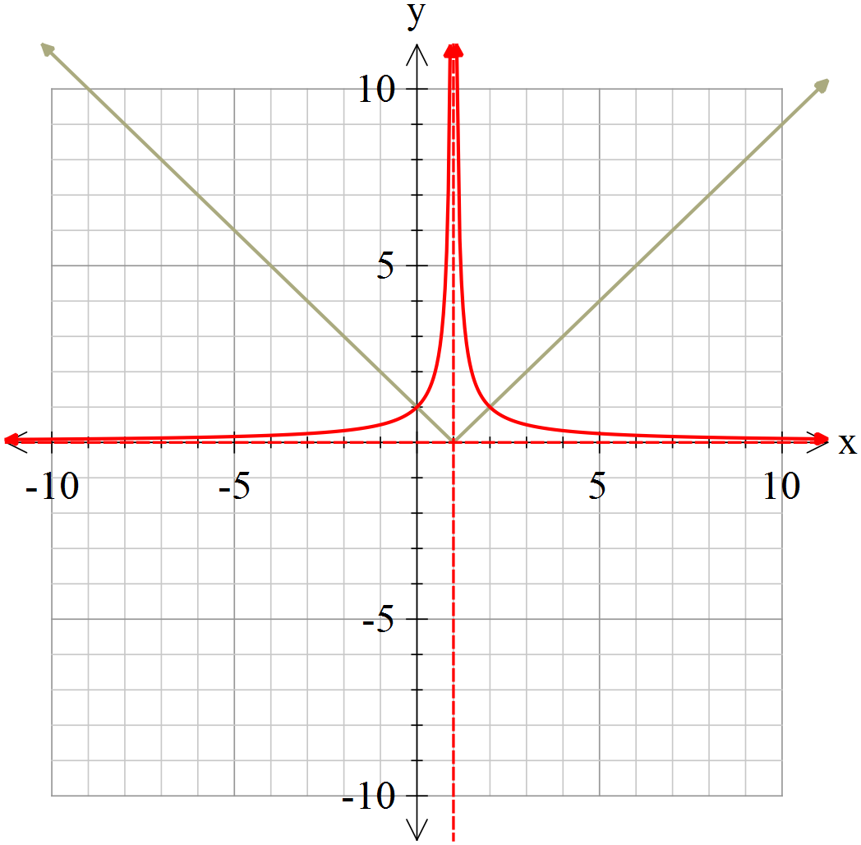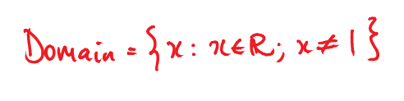



**Question 6 [2 marks]**

Sketch the graph of  given that as shown on the graph below.

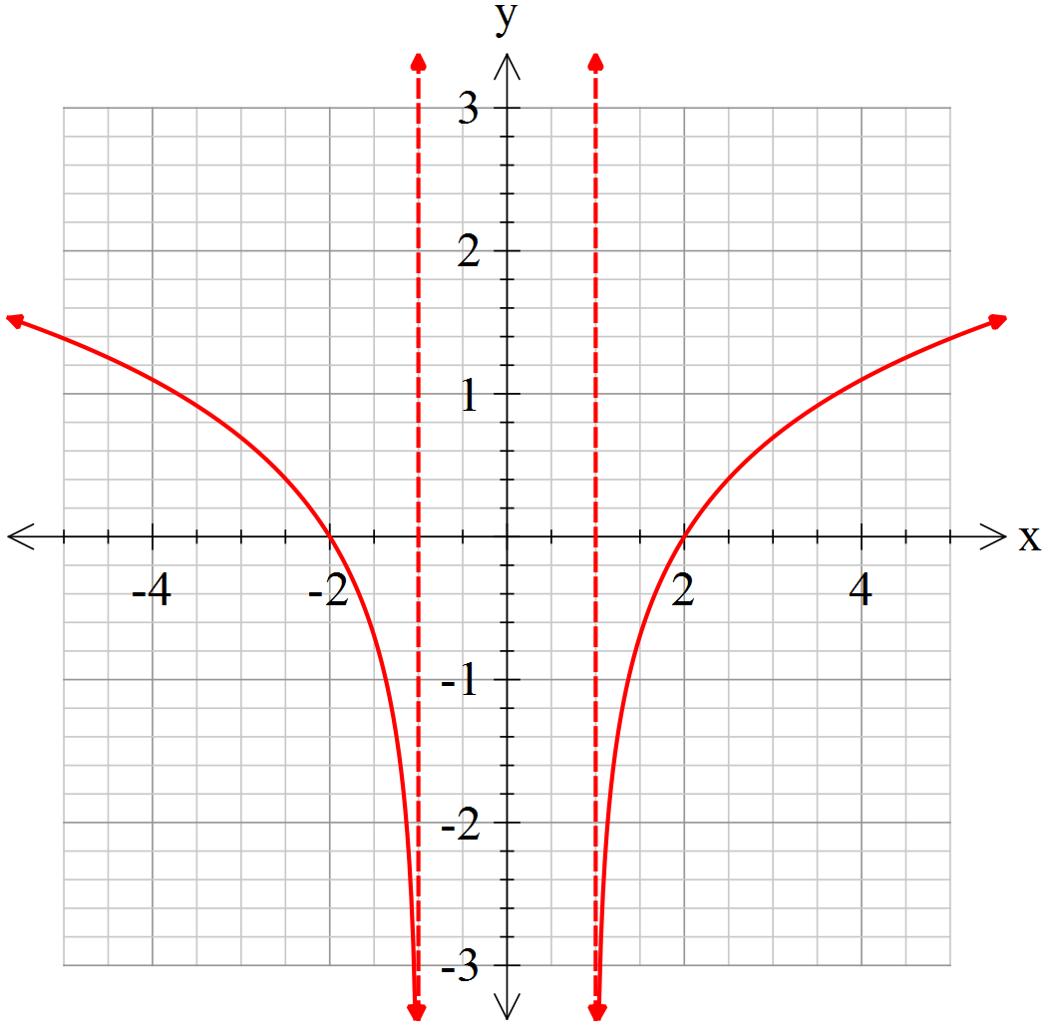





|  |
| --- |
| **Year 12 Mathematics Specialist 2017**  **Test Number 2: Functions and Graph Sketching**  **Resource Rich** |

**Name: _______Solutions____________________________ Teacher: DDA**

**Marks: 20**

**Time Allowed: 23 minutes**

**Instructions:** You are permitted 1 A4 pages of notes and your calculators. Show your working where appropriate remembering you must show working for questions worth more than 2 marks.

_________________________________________________________________________

**Question 7 [1 mark]**

Circle all of the choices A-E which are true of the following statement.

A function can be identified as one-to-one if, for all values in the domain,

A . B . C .

D . E .

**Question 8 [1, 2 = 3 mark]**

Is the function one-to-one?

Justify your answer.

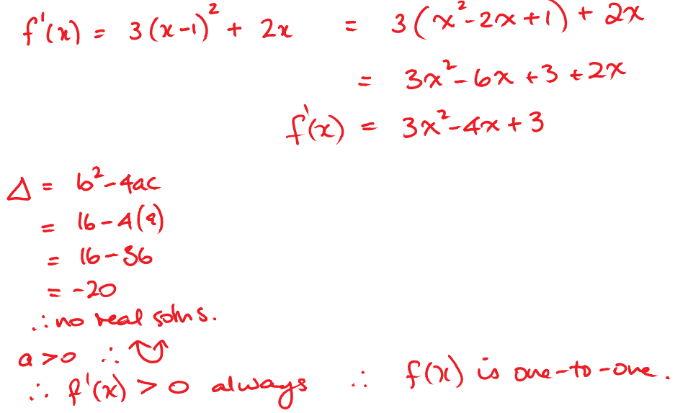



**Question 9 [1, 1, 3, 3, 2 = 10 marks]**

Given 

1. Find the following:
   1. Intercepts:
   2. 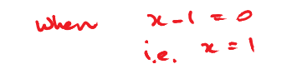Vertical asymptotes:
   3. 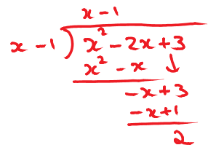Behaviour of as (including any oblique asymptotes):

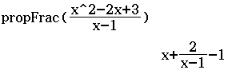

or

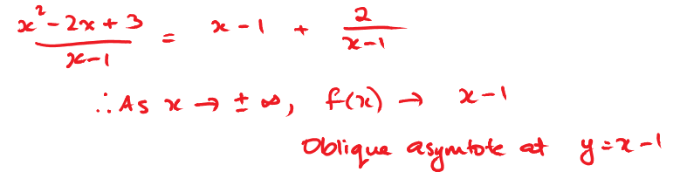



* 1. 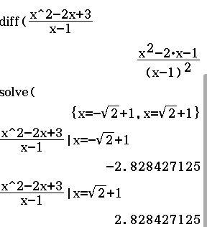Stationary points (accurate to 1 d.p.):



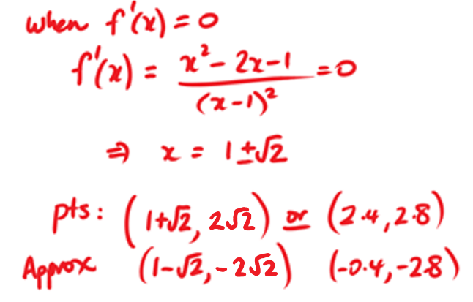



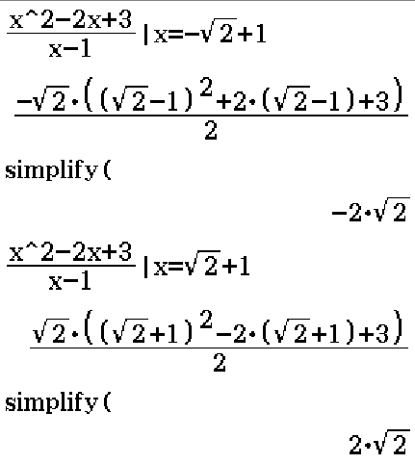



1. Hence, sketch the graph of.

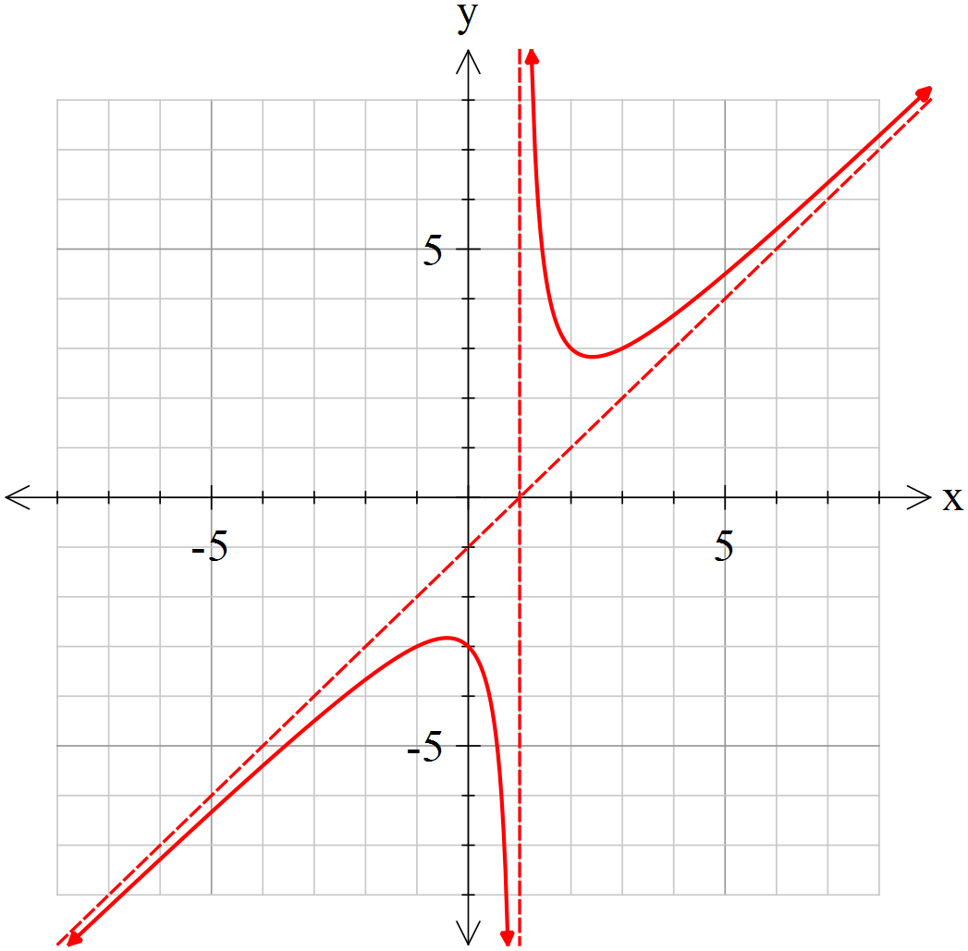

Required:

* y-int
* 2 asymptotes
* TPs
* Sketched in with arrows

**Question 10 [3 marks]**

If the number line drawn below represents the solution to the equation , where represents an inequality symbol find the values of and and also determine which symbol represents.

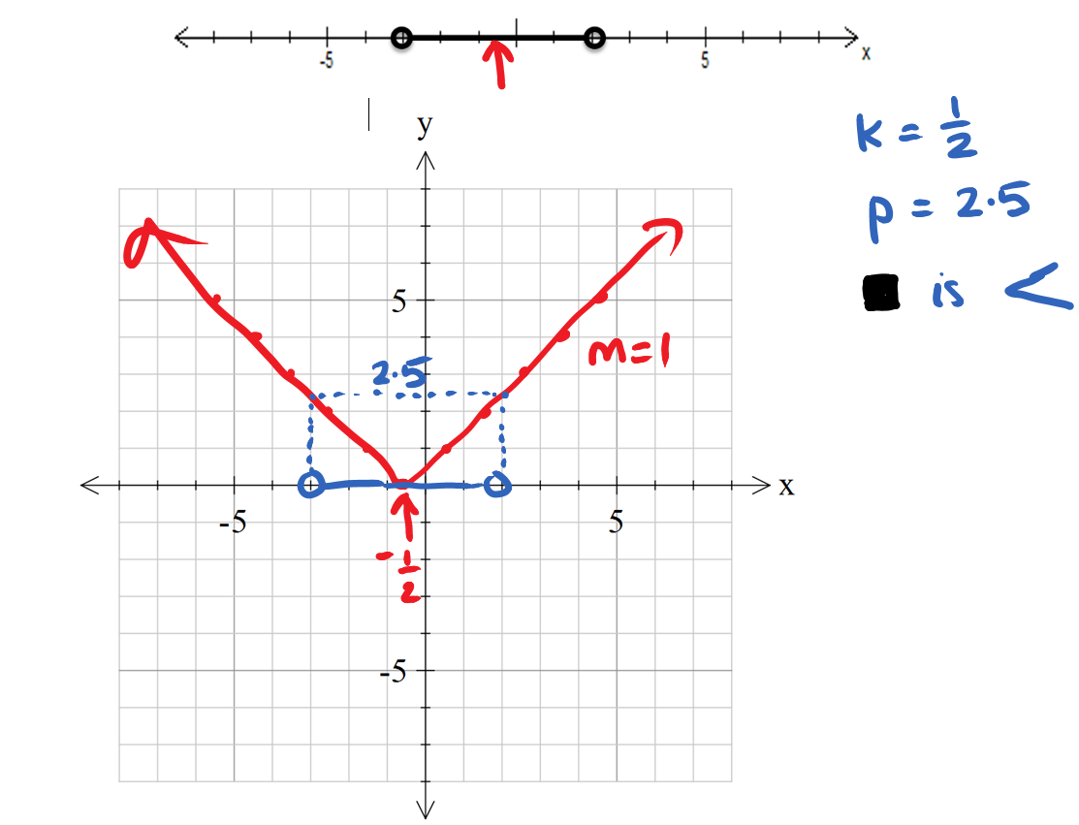

**0.5**

**Question 11 [3 marks]**

Given that is true for only, what are the values of and ?

You may wish to use the grid below.

